AI-Enhanced Recruitment Systems: Transforming Online Hiring Processes with Intelligent Automation for Improved Talent Acquisition and Efficiency

Y Jayakrishna
Artificial Intelligence and Data Science Department
Annamacharya Institute of Technology and Sciences
Rajampet, India
yjayakrish@gmail.com
S Raju
Artificial Intelligence and Data Science Department
Annamacharya Institute of Technology and Sciences
Rajampet, India
rajujhon329@gmail.com
K Divyendra
Artificial Intelligence and Data Science Department
Annamacharya Institute of Technology and Sciences
Rajampet, India
divyendrapandu@gmail.com
Ms. N Swathi (Assistant professor)
Artificial Intelligence and Data Science Department
Annamacharya Institute of Technology and Sciences
Rajampet, India
Swathiswaroma@gmail.com
S Mahammad
Artificial Intelligence and Data Science Department
Annamacharya Institute of Technology and Sciences
Rajampet, India
mahammadsaddaladineemahammad@gmail.com

Abstract— AI-Enhanced Employment Systems evolving Online Hiring Process with Intelligent Robotics for Improved Acquisition of Talent and Efficiency offers a state-of-the-art way to improve hiring procedures in the ever-evolving talent acquisition market. This study presents a novel system that uses machine learning methods, namely TF-IDF (Term Frequency-Inverse Document Frequency) and KNN classifier to improve and automate resume evaluation in a variety of fields, including analytics, data science, machine learning, and Java. The system uses extensive preprocessing methods to guarantee the quality of the data, and then TF-IDF is used for efficient text vector processing and feature extraction. Resumes are ranked by the KNN according to their relevance and subject expertise. It has demonstrated remarkable accuracy, scoring 89% on trainer data and 82% on test data. The use of a word cloud image enhances the analysis by emphasizing essential phrases and competencies, and an intuitive streamlit user interface expedites the upload and assessment of resumes. The technology makes actionable suggestions concerning whether to accept or reject individuals based on their alignment with job criteria in addition to providing comprehensive domain-specific ratings. This strategy is a useful tool for contemporary HR procedures as it not only improves the impartiality and efficiency of decision-making, but also speeds the hiring process.
Keywords— Acceptance, Automation, Classification, Machine Learning, Resume Evaluation, Streamlit, Talent Acquisition and Word-cloud

Introduction
The fields of machine learning and artificial intelligence have revolutionized several fields, including recruiting. Handwritten resume screening is a common component of traditional recruiting procedures, although it may be laborious and biased. Intelligent automation [1] is used by sophisticated recruiting systems to overcome these issues and simplify the hiring procedure. The basic idea behind these systems is to transform textual data into a format that can be used with machine learning models by utilizing natural language processing (NLP) techniques like TF-IDF (Term Frequency-Inverse Document Frequency) [2]. These technologies are designed to improve the impartiality and efficiency of hiring by evaluating resumes according to their content and alignment with job descriptions.
Efficient and precise recruitment tools are essential in today's job market. Conventional approaches frequently find it difficult to keep up with the number applications received and the increasing variety of job roles. Recent industry figures show that integrating AI-driven technologies [3] may boost recruiting efficiency by as much as 50% on average for firms. Furthermore, by cutting the time-to-hire by around 30%, these solutions can solve the widespread problem of drawn-out hiring procedures. AI-enhanced recruiting solutions help businesses make better hiring decisions by automating the screening of resumes and offering data-driven insights. This improves hiring results overall and lowers operating expenses for the firm. The study investigates a cutting-edge strategy for modernizing hiring procedures. In order to assess and rank resumes in a variety of fields, such as analytics, machine learning, data science, and Java, this study uses TF-IDF and KNN [4]. Through extensive preprocessing methods, the system guarantees the precision and applicability of the data examined.
The KNN shows how successful this method is in properly evaluating resume content and matching it with job criteria, with a success rate of 89% on training data and 82% on test data. In addition, the system has a word cloud representation to emphasize essential concepts and abilities, and it has an easy-to-use streamlit user interface [5] for a smooth resume submission and assessment process. In addition to providing thorough domain-specific ratings, this all-encompassing method includes practical suggestions for admitting or rejecting applicants. This research addresses the shortcomings of conventional approaches and satisfies the changing requirements of contemporary HR departments by augmenting the hiring process with intelligent automation. This leads to the creation of more effective, impartial, and data-driven hiring processes.

literature survey
Automated recruiting systems have come a long way in the past, using a variety of machine learning and natural language processing approaches to increase hiring process efficiency. The main emphasis of early efforts was screening resumes using keyword-based filters [6] and simple text matching algorithms. These algorithms compared resume content with predetermined job requirements in an effort to find qualified individuals. Unfortunately, these methods frequently suffered from shortcomings as a result of their incapacity to fully grasp the text's complex context and semantic meaning, which resulted in less than ideal performance when it came to finding qualified applicants. Krishnan et al. examines how AI affects HR productivity and worker satisfaction, with a particular emphasis on how AI is integrated into hiring, onboarding, performance management, and talent development procedures [7]. It offers important information for businesses looking to use AI in people development, including insights on the benefits and difficulties of integrating AI. Natarajan et al. investigates the use of artificial intelligence (AI) to personnel management with the goal of streamlining the hiring, training, and retention procedures. Recruitment, predictive analytics, tailored instruction, managing performance, retention, management of succession, and diversity efforts [8] are among the AI-powered tactics covered in this article.
As technology developed, more advanced techniques were added, including machine learning models like Random Forests and Support Vector Machines (SVMs). These models improved the capacity to rank and categorize resumes according to several characteristics that were taken from the text, such as education, experience, and talents. Furthermore, the development of sophisticated natural language processing methods like word embeddings and TF-IDF made it possible to represent textual data more accurately and raised the standard of resume evaluation. In addition, these methods started to include several pretreatment stages to clean and standardize the data, resolving some of the previous issues with data consistency and quality. Rayyan et al. report looks at how AI and ML are affecting hiring in Indonesia's e-commerce industry, and it identifies issues [9] with data quality, model accuracy, and system flexibility. Gupta et al. built an application of AI in hiring procedures is examined in this thesis, with an emphasis on candidate quality and efficiency [10]. It assesses how it affects hiring time and cost per recruit in addition to its usefulness, providing guidance for tactical talent acquisition.
Through the integration of sophisticated algorithms and deep learning models, recent advancements have further improved recruiting systems by automating and streamlining the hiring process. In order to comprehend and evaluate resumes more efficiently, these systems increasingly make use of artificial neural networks and transformer-based models. This allows them to pick up on minute semantic details and deliver suggestions that are more precise. The usefulness of these systems has been improved by the addition of visualization tools, such as word cloud, and user-friendly interfaces [11], which make it simpler for HR professionals to understand the data and make wise decisions. These developments provide more dependable and effective answers for contemporary recruiting difficulties, marking a substantial step forward from previous approaches. Safitri et al. investigates the effects of AI integration and a high-performance work system on hiring and performance reviews of employees. It emphasizes AI's potential to improve HRM procedures, especially in hiring and performance review [12], by drawing on research on healthcare. The study offers both practical and theoretical insights, but further investigation is required to fully grasp the effectiveness of AI and its consequences for hiring practices and performance reviews in businesses. Halid et al. proposed an AI usage in HR procedures is increasing as a result of organizations' adaptation to online platforms and IT developments [13]. By fusing humans and computers, artificial intelligence (AI) seeks to improve efficiency, productivity, and usability. HR specialists are concentrating on streamlining both automatic and manual tasks to create a more user-friendly atmosphere.

DATA COLLECTION & PREPROCESSING

The main goal of the AI-enhanced recruiting system's data gathering and preparation phase (as shown in Fig.1) is to get textual data from job descriptions and resumes ready for efficient analysis and modeling. The first step in this approach is to compile a varied and representative collection of job descriptions and resumes from a range of industries, including analytics, machine learning, data science, and Java [14]. To guarantee a wide and diverse sample, the dataset is usually gathered from a number of sources, such as resume databases, corporate career pages, and internet job boards. This variety is essential for developing a strong model that can correctly handle various résumé formats and job descriptions. The dataset is first cleaned once it is gathered to get rid of any unnecessary or superfluous data. In this stage, duplicate items are removed, formatting errors are fixed, and any non-textual stuff that doesn't add value to the analysis is discarded. For example, headers, footers, and other extraneous components are removed so that the resumes and job postings only include the most important information.
In order to create a trustworthy and efficient model, it is imperative that the data utilized for further processing be both consistent and relevant, which is ensured by this cleaning procedure. Text normalization is the next step, which entails converting the unprocessed text data into a standardized format that can be used for analysis. Several crucial methods are used in this normalization process, including lowercasing all text to guarantee consistency, getting rid of the punctuation and unique characters [15] that might not add to the semantic meaning, and getting rid of stop words, which are words like "and," "the," or "is" that are commonly used but have little meaning when it comes to text analysis. These methods standardize the data, which facilitates comparison and analysis.
Tokenization is the process that divides the text into discrete pieces, or tokens, such words or phrases, after normalization. The process of tokenization is essential because it converts text that continues into discrete parts that are easier to examine. Tokenizing a CV into individual words, for example, enables the system to assess the frequency and significance of particular concepts and abilities. Applying other text processing methods, such feature extraction and phrase frequency analysis, is also made easier by tokenization. The textual input must next be transformed into numerical representations so that machine learning algorithms can process it after tokenization is finished. Word embeddings and Term Frequency-Inverse Document Frequency (TF-IDF) are two methods [16] used to accomplish this conversion. To measure a term's significance in a text in relation to its frequency throughout the full dataset, TF-IDF is utilized. This technique highlights phrases that are more important for differentiating between resumes and job descriptions by giving larger weights to terms that are common in a given document but uncommon throughout the collection. Word embeddings like Word2Vec or Glo-Ve can also be used to represent words equally dense vectors in continuous space, in addition to TF-IDF. The system is able to comprehend and evaluate the environment in which terms are employed since these embeddings record the semantic links between words.
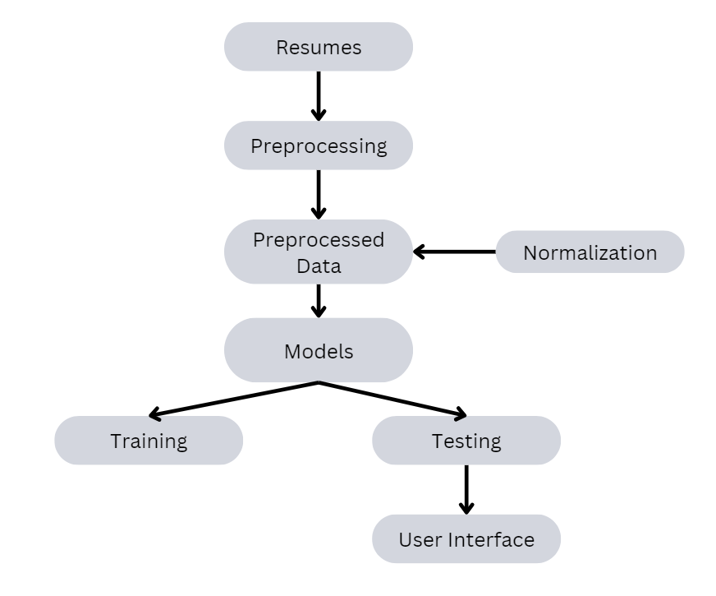
Fig.1 Architecture
This way of expressing words helps the model better catch the subtleties and similarities of phrases, which results in analysis that is more accurate and pertinent to the context. Following the conversion of the text into numerical visualizations, the extraction and selection of features are applied to the data. This procedure entails locating and picking the most pertinent characteristics or features from the numerical information that enhance the functionality of the model. While feature selection concentrates on keeping just the most significant features for the classification process [17], feature extraction strategies may involve recognizing critical abilities, credentials, as well as experience from the applications and job descriptions. The dataset used for testing is used to evaluate how well the model performs and how well it can generalize to new data. Through this assessment, the model's ability to correctly categorize and evaluate applications according to domain-specific standards is confirmed, offering insightful analysis and suggestions for the hiring process.

PRINCIPLES AND METHODS
Two fundamental ideas underpin the AI-enhanced recruiting system: K-Neighbors-Classifier and Term Frequency-Inverse Document Frequency (TF-IDF), both of which is essential to the system's operation. Finding the importance of words in texts is the foundation of the TF-IDF concept. Through the process of computing the regularity of terms both within a given document and over a broader corpus, TF-IDF assists in emphasizing terms that are especially pertinent to individual texts. With this dual-measurement technique, common, less informative phrases are minimized while terms with high specificity and relevance are given the proper weight. With this approach, the system may more precisely identify and measure the significance of different talents and credentials by addressing the problem of identifying relevant material in resumes and job descriptions. Processing the text data is the first stage in the process of applying TF-IDF to the recruiting system.
This includes normalization procedures like deleting stop words, converting text to lowercase, and removing punctuation. TF-IDF vectors are calculated for every phrase in the job descriptions and resumes following preprocessing. Based on terms' frequency both inside and throughout the dataset, these vectors offer a numerical depiction of word relevance. Effective resume scoring and categorization depends on the system's ability to evaluate and rank phrases based on their relevance, which is made possible by the generated TF-IDF scores. Regarding classification, the K-Neighbors-Classifier employs instance-based learning, which means that it makes predictions directly from the training data instead than constructing a generalization manually. The classifier uses a selected distance measure, such Euclidean distance, to determine which of the 'k' closest samples used for training are to a given new data point.
A whole procedure is required to incorporate these concepts into the hiring process, and it begins with gathering and preparing text data from job descriptions and resumes. To indicate a term's relevance, TF-IDF vectors are created and subsequently fed into the K-Neighbors-Classifier as input features. After assessing these characteristics, the classifier gives each resume a domain-specific score. In order to streamline user engagement with the categorization tool, the system also includes a streamlit user interface. This interface enables HR professionals to submit resumes, check domain-specific ratings, and make well-informed judgments. A great deal vote among these closest neighbors is then used to determine the categorization, with the option to weight results to give closer neighbors greater sway. This approach makes use of the notion that instances that are similar are likely to belong to the same class, which makes it a good fit for tasks like resume categorization where a candidate's resemblance to the job criteria is an important consideration.

TF IDF VECTORIZER

A popular method in text processing and information retrieval, Term Frequency-Inverse Document Frequency (TF-IDF) [18], assesses a word's significance in a document in relation to a corpus, or group of documents. Finding important words inside a given text while reducing the weight of phrases that appear often in all papers is the main objective of TF-IDF. This method aids in separating terms that are significant within individual documents from terms that are prevalent throughout the collection. Two fundamental elements form the foundation of TF-IDF: Term Frequency (TF) and Inverse Document Frequency (IDF). A term's frequency of occurrence in a document is measured by term frequency. This is predicated on the idea that phrases that crop up frequently in an article are probably more pertinent to the substance of that document. For example, if a resume uses the word "Data Science" several times, it indicates that the document considers this to be significant. But TF by itself doesn't take into account a term's frequency or rarity over the full set of texts.
Conversely, Inverse Document Frequency measures how common or uncommon a phrase is across every document in the corpus, so addressing the restriction of phrase Frequency. Terms that are used frequently in papers are probably less useful because they don't offer specific details about any one document. those that are uncommon and show up in fewer documents are given a greater weight by IDF, whereas those that are more prevalent are given a lower weight. This aids in highlighting phrases unique to certain papers opposed to those that are overly generic. When TF and IDF are combined, a value is produced that takes into account a term's significance inside a particular text as well as its rarity throughout the corpus. Text processing systems may efficiently emphasize phrases that are distinctive to a certain document while lessening the influence of common terms by utilizing TF-IDF. Because of this, TF-IDF is very helpful for applications like text mining, information retrieval, and document categorization.
TF-IDF is a useful technique for converting text input into numerical characteristics that machine learning models may use. A document's terms are given a TF-IDF score that indicates how relevant they are. The document collection's feature matrix is then created using these scores, with each row denoting an item of paper and each column a phrase from the corpus. Many machine learning algorithms use this matrix as their input. The ease of use and efficiency of TF-IDF in identifying the significance of phrases inside a text is one of its benefits. In contrast to more intricate models, TF-IDF offers a simple method of text representation that strikes a balance between word frequency and document rarity. This makes it an effective and user-friendly tool for a variety of text analysis applications, particularly those involving substantial amounts of text data.
TF-IDF has drawbacks even with its efficacy. For instance, it is unable to convey the context or semantic meaning of phrases that are used more frequently than that. Additionally, it handles each phrase on its own without taking into account how it relates to other terms in the text. Although more sophisticated methods like word embedding and deep learning models have been devised to overcome these constraints, TF-IDF is still a fundamental tool in text processing. All things considered, TF-IDF is a useful text analysis method for assessing the significance of phrases both inside and between publications. It is a vital approach for tasks like text categorization, keyword extraction, and document retrieval since it may weigh phrases according to their distribution and frequency. TF-IDF facilitates the creation of efficient information retrieval systems and aids in the extraction of valuable insights from text data by highlighting unique phrases and downplaying common ones.

B. KNN CLASSIFIER
One popular machine learning technique that is a member of the instance-based learning family also known as lazy learners is the K-Neighbors-Classifier [19]. The KNN makes predictions straight from the training data, in contrast to many other methods that construct a model based on the training set. It uses the idea of "nearest neighbors" to categorize fresh data points based on the similarity principle. It is therefore a well-liked option for classification jobs when simplicity and interpretability are important. Fundamentally, the KNN (as shown in Fig.2) predicts new data points by comparing them to their most adjacent neighbors in the feature space. The method finds the 'k' closest training samples to a given location when a fresh sample has to be categorized. Metrics like Euclidean distances are commonly employed to quantify the "distance" between points, however depending on the task and the type of data, alternative distance measures like Manhattan or Minkowski may also be utilized.
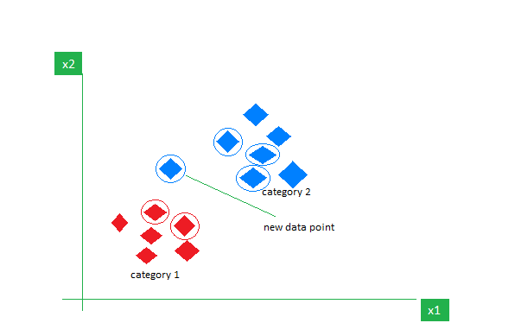
Fig.2 KNN Classifier
A crucial element in the KNN is the selection of 'k', or the number of neighbors to take into account. If 'k' is too little, overfitting might result from the model being unduly dependent upon noise in the data. In contrast, if 'k' is very big, the model could become underfit and overly generalized because it includes an excessive number of neighbors in the decision-making process. Choosing the best number for 'k' frequently requires trial and error as well as validation methods like cross-validation to strike a balance between variance and bias. The K-Neighbors-Classifier determines the class of the new data point by averaging the labels of its 'k' nearest neighbors before classifying [20] it. A majority voting technique is usually used for this aggregation, and the class that emerges the most frequently among those around it is allocated to the new sample. An alternative is to use weighted voting, in which neighbors who are closer to the fresh location are given more weight in determining the final categorization outcome.
The K-Neighbors-Classifier's simplicity and convenience of use are two of its main benefits. Because it makes no assumptions on the data's distribution, it is adaptable and suitable to a wide range of issues. In order to guarantee that each feature contributes equally to the distance computations, feature scaling techniques like standardization or normalization can also frequently enhance the algorithm's performance. The K-Neighbors-Classifier does, however, have certain drawbacks. Finding the closest neighbors becomes increasingly computationally expensive as the quantity of training samples rises. Slower prediction times may result from this, particularly for big datasets. In order to address this problem, methods like KD-trees or Ball-trees can be applied to speed up the algorithm's search for nearest neighbors.
The K-Neighbors-Classifier's sensitivity to superfluous or unnecessary characteristics presents another difficulty. The findings might be disproportionately affected by features with differing sizes or units because the technique depends on distance computations. Therefore, in order to guarantee that the classifier operates at its best, it is crucial to properly preprocess the data, including choosing features and scaling. Using the concept of closeness to generate predictions, the K-Neighbors-Classifier is a simple and efficient method for classification problems. Its versatility and readability make it a popular option for many applications; nevertheless, in order to get the best results, it has to be carefully optimized with regard to factors like 'k' and suitable data preparation. Users may employ the K-Neighbors-Classifier to tackle a variety of classification issues and get insightful information from their data by being aware of its advantages and disadvantages.

RESULTS
The outcomes of the TF-IDF and K-Neighbors-Classifier-powered AI-enhanced hiring system provide a thorough understanding of how well it automates and enhances the hiring process. The system seeks to offer a data-driven, objective assessment of resumes according to their applicability to particular job categories including analytics, machine learning, data science, and Java. The creation of a powerful tool that reliably rates and categorizes resumes will be the main result of our effort, helping HR managers make better recruiting decisions. By measuring word relevance, the TF-IDF implementation allows the system to assess the significance of phrases in resumes and job descriptions. Through the process of giving greater weights to phrases that are unique to a given document and less frequent throughout the corpus, the methodology is able to determine which core competencies are essential for each industry. By using this strategy, the recruiting system may concentrate on keywords that indicate a candidate's fit for a certain position, improving the scoring process for resumes.

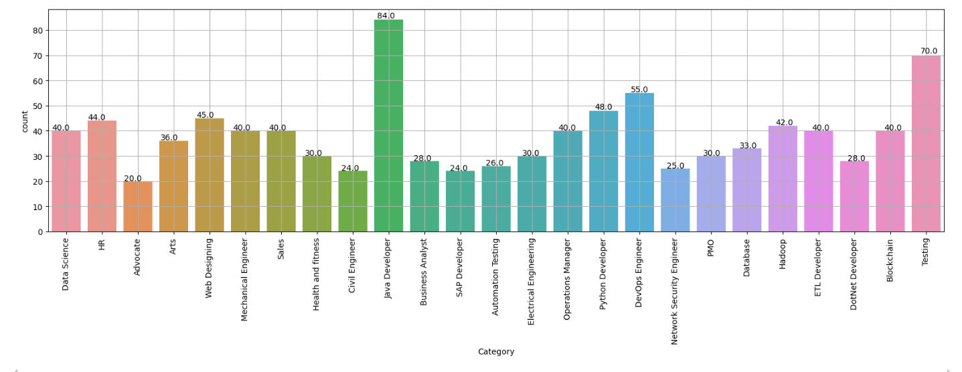
Fig.3 Count Plot of skills

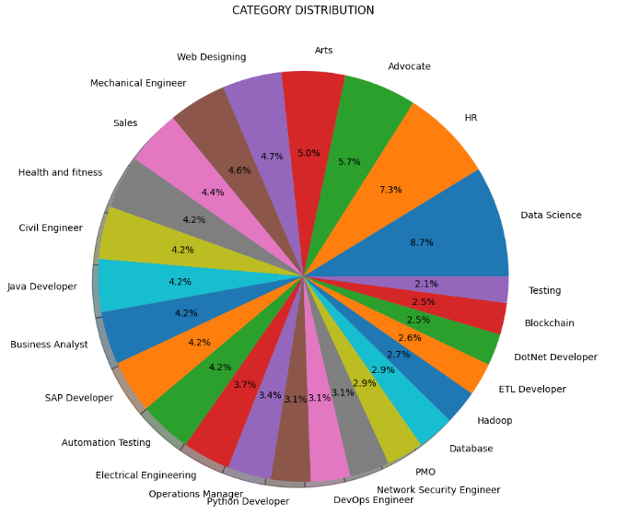
Fig.4 Pie Plot of Job Roles


Fig.5 Word Cloud of Resume

Significant performance metrics are attained by the K-Neighbors-Classifier, which is used to categorize resumes based on the scores obtained by TF-IDF. The classifier shows promise in differentiating applicants based on resume content, with 89% accuracy on train data and 82% accuracy on test data. This high degree of accuracy shows that the system can effectively help the hiring process by evaluating resumes with consistency and generating pertinent ratings for a range of job categories. The outcomes also emphasize how crucial parameter tweaking is, especially when deciding on the ideal value for "k" in the K-Neighbors-Classifier. The system makes sure the classifier is well-calibrated in order to negotiate the trade-off of overfitting and underfitting by exploring with different values of 'k' and assessing the model's performance.
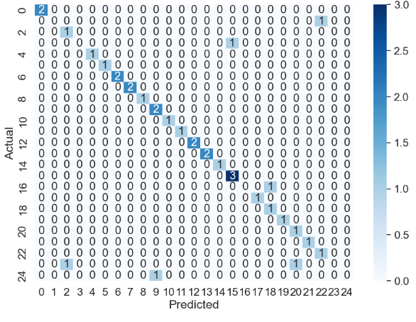
Fig.6 Confusion Matrix

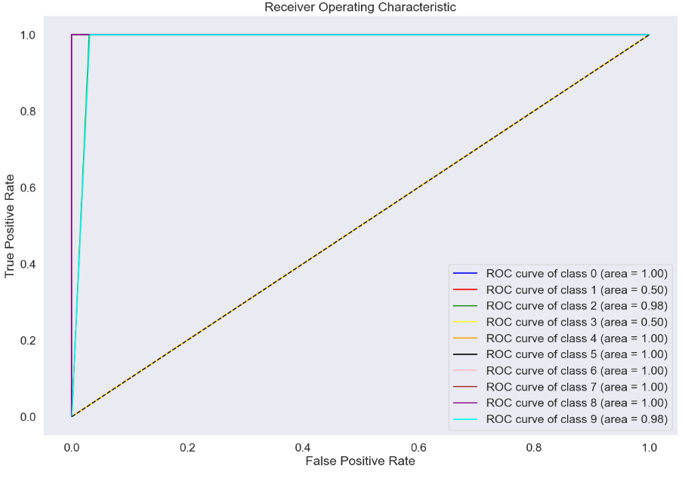
Fig.7 ROC Curve
Apart from its categorization and grading features, the system also has an intuitive streamlit interface (as shown in Fig.8) that makes the product easier to use and more accessible. HR managers and users may effortlessly engage with the system through the streamlit UI, submit resumes, and obtain prompt feedback on a candidate's fit for particular job categories. Without necessitating a high level of technical knowledge, our user-friendly interface makes resume assessment easier and more efficient for users. A seamless user experience is the goal of the streamlit UI, which includes elements like interactive displays, file upload buttons, and educational visualizations. Through the portal, users may submit resumes directly. The system uses these files to provide domain-specific ratings.
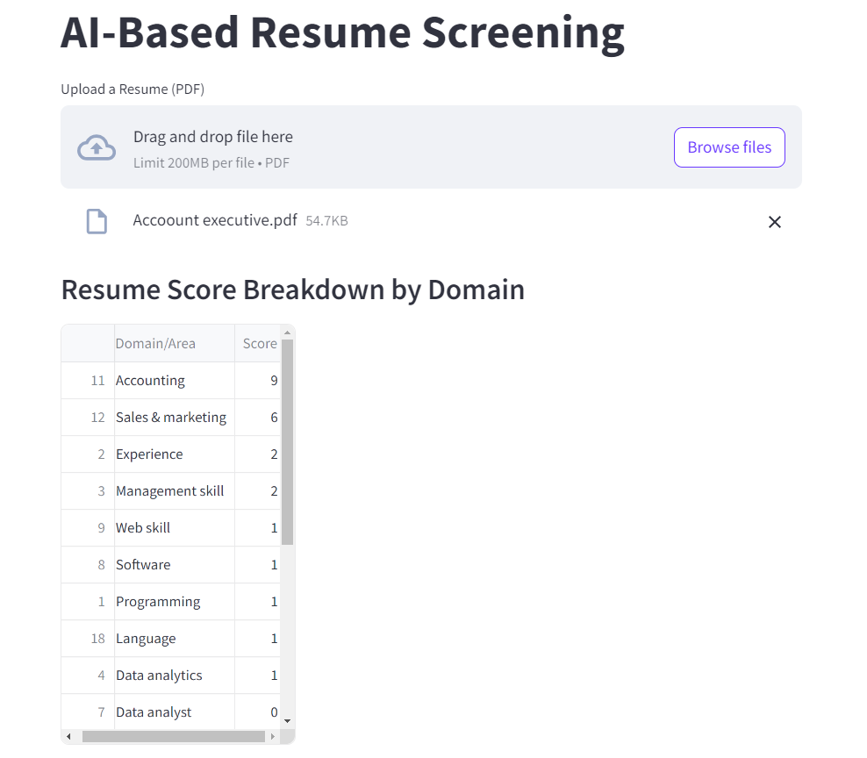
Fig.8 Streamlit User Interface
Moreover, the user interface (UI) has graphic components such as word cloud, which offers a graphical depiction of important phrases and abilities taken from the resumes. Users may immediately recognize the most crucial phrases and rapidly grasp the resumes' content thanks to this display. The addition of these visual components to the streamlit interface improves user experience overall and offers insightful information about the resume screening procedure. The investigation's outcomes also highlight how well TF-IDF and K-Neighbors-Classifier together function for recruiting. The system's ability to correctly evaluate and categorize resumes according to their content shows how well this strategy has worked to solve the drawbacks of conventional hiring practices.
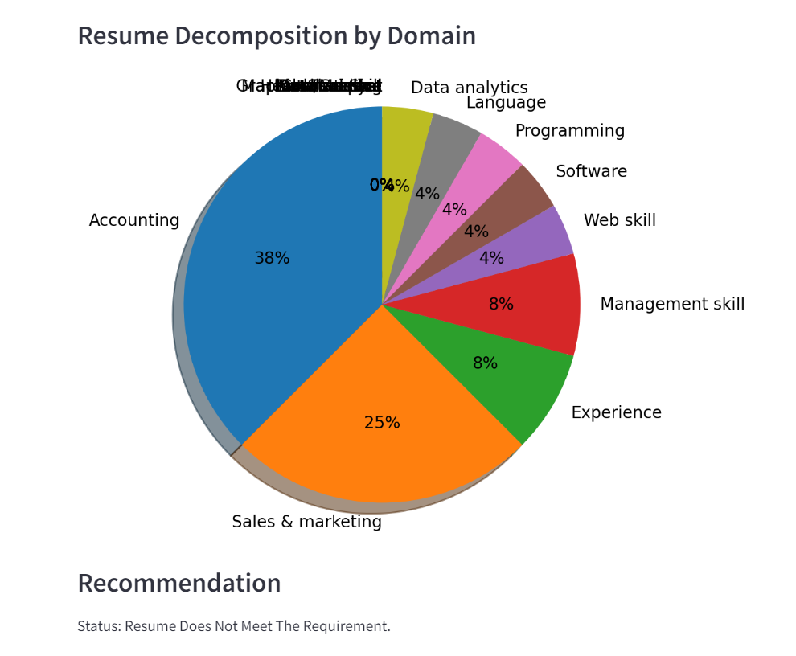
Fig.9 Resume Screening

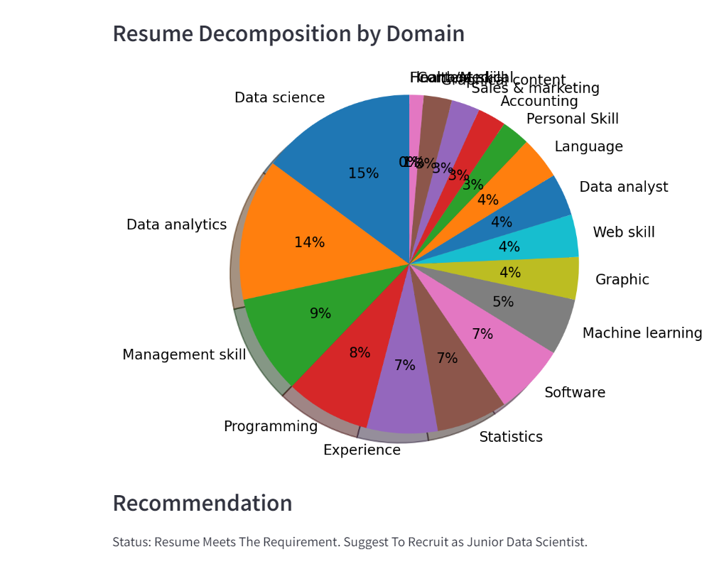
Fig.10 Resume Screening
Furthermore, the recruiting system's use of the streamlit UI showcases the capacity of user-friendly interfaces to increase accessibility to cutting-edge technology. The user interface (UI) makes resume review simple, which encourages system adoption and lets HR professionals make the most of the system's features. The strategy has the potential to greatly improve hiring procedures and boost overall efficiency, according to the system's performance data and user reviews. The efficiency of integrating TF-IDF and K-Neighbors-Classifier for computerized resume evaluation is demonstrated by the AI-enhanced recruiting system. The system offers a complete answer for contemporary recruiting issues because to its high accuracy and user-friendly streamlit UI (as shown in Fig.9 & 10). The technology helps HR professionals make more informed and effective recruiting decisions by addressing significant challenges in the hiring process and providing dependable categorization, perceptive visualizations, and an intuitive user interface.

CONCLUSION
The employment process may now be automated and optimized thanks to the AI-enhanced employment system that uses K-Neighbors-Classifier and TF-IDF. With 89% accuracy on learning data and 82% accuracy on test data, the effective integration of TF-IDF for measuring and extracting term significance from resumes and the K-Neighbors-Classifier for precise classification has shown a high degree of performance. This methodical technique efficiently addresses the shortcomings of traditional recruiting approaches by differentiating applicants according to their qualifications and eligibility for different job categories. The system's usability is further improved with the addition of an intuitive streamlit interface, which enables HR professionals to quickly submit resumes, examine comprehensive evaluations, and make well-informed selections. The technology facilitates objective and data-driven recruiting processes while streamlining the hiring process by automating resume screening, minimizing biases, and offering enlightening visualizations. All things considered, the study shows how cutting edge text processing methods combined with user-friendly interfaces may transform talent acquisition and boost recruiting efficiency in general.

References

- Jha, Nishant, Deepak Prashar, and Amandeep Nagpal. "Combining artificial intelligence with robotic process automation—an intelligent automation approach." Deep learning and big data for intelligent transportation: enabling technologies and future trends (2021): 245-264.
- Alfarizi, Muhammad Ibnu, Lailis Syafaah, and Merinda Lestandy. "Emotional text classification using tf-idf (term frequency-inverse document frequency) and lstm (long short-term memory)." JUITA: Jurnal Informatika 10.2 (2022): 225-232.
- Huang, Ziqi, et al. "A survey on AI-driven digital twins in industry 4.0: Smart manufacturing and advanced robotics." Sensors 21.19 (2021): 6340.
- Sari, I., and R. Kosasih. "Prediction types of legal cases in Indonesia using the TF-IDF method and the KNN algorithm." AIP Conference Proceedings. Vol. 2689. No. 1. AIP Publishing, 2023.
- Data, Build Web-Based, and Sujay Raghavendra. "Beginner’s Guide to Streamlit with Python."
- Daryani, Chirag, et al. "An automated resume screening system using natural language processing and similarity." ETHICS AND INFORMATION TECHNOLOGY [Internet]. VOLKSON PRESS (2020): 99-103.
- Krishnan, L. R. K., K. Praveen, and S. Poorani. "Artificial Intelligence in Human Resource Management: Enhancing Efficiency & Transforming Employee Experience." LRK Krishnan, Praveen K & Poorani S (2024).
- Sundarapandiyan Natarajan, Dr Korapu Sattibabu, et al. "AI-Powered Strategies for Talent Management Optimization." Journal of Informatics Education and Research 4.2 (2024).
- Rayyan, Mohammad, Nakayenga Sharifah, and Rini Kuswati. "Revolutionizing Talent Acquisition in Indonesia's E-Commerce Industry: The Transformative Impact of AI and Machine Learning." Journal of Humanities and Social Sciences Studies 6.4 (2024): 01-12.
- Gupta, Aishwarya, and Kimiya Rahimi Ata. "Data-Driven Hiring: Implementing AI and Assessing the Impact of AI on Recruitment Efficiency and Candidate Quality." (2024).
- Jin, Yuping. "Development of word cloud generator software based on python." Procedia engineering 174 (2017): 788-792.
- Safitri, Indah, Hafidz Widodo, and Muafi Muafi. "Application of High-Performance Work System with AI in Employee Recruitment and Performance Evaluation." Technology-Driven Business Innovation: Unleashing the Digital Advantage, Volume 1. Cham: Springer Nature Switzerland, 2024. 465-473.
- Halid, Hafinas, et al. "Artificial Intelligence (AI) in Human Resource Management (HRM)." Building the Future with Human Resource Management. Cham: Springer International Publishing, 2024. 37-70.
- Kamath, Uday, and Krishna Choppella. Mastering java machine learning. Packt Publishing Ltd, 2017.
- Lapworth, Katherine. The Writer's Guide to Good Style: A 21st Century guide to improving your punctuation, pace, grammar and style. Hachette UK, 2019.
- Havrlant, Lukáš, and Vladik Kreinovich. "A simple probabilistic explanation of term frequency-inverse document frequency (tf-idf) heuristic (and variations motivated by this explanation)." International Journal of General Systems 46.1 (2017): 27-36.
- Li, Jundong, et al. "Feature selection: A data perspective." ACM computing surveys (CSUR) 50.6 (2017): 1-45.
- Hakim, Ari Aulia, et al. "Automated document classification for news article in Bahasa Indonesia based on term frequency inverse document frequency (TF-IDF) approach." 2014 6th international conference on information technology and electrical engineering (ICITEE). IEEE, 2014.
- Sharma, Siddharth. "Using Quantum Computing to Enhance ML Classifiers and Feature Spaces."
- Nkemnole, E. B., J. T. Wulu, and I. Osubu. "Application of K-Nearest Neighbours and Long-Short-Term Memory Models using Hidden Markov Model to Predict Inflation Rate and Transition Patterns in Nigeria." Journal of Applied Sciences and Environmental Management 28.6 (2024): 1913-1925.

